**According to CNN, Cristiano Ronaldo sued over alleged rape.**

**STARTING**

[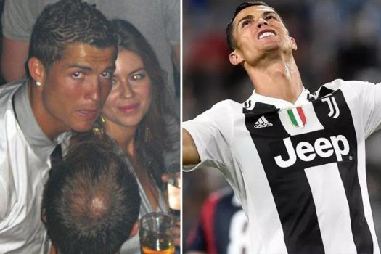](https://1.bp.blogspot.com/-iVfnXzz-1z0/W7Tp5d3bshI/AAAAAAAAAH4/YnFS-q614tYSpI5uHxUPwDzdyemNZ2xnwCLcBGAs/s1600/cristiano-ronaldo-hired-detectives-to-spy-on-rape-accuser-kathryn-mayorga-and-dig-up-dirt-as-lawyers-pressured-cops-to-drop-case.jpg)

**June 13,2009**

[**Cristiano Ronaldo**](https://en.wikipedia.org/wiki/Cristiano_Ronaldo) invited model [**Kathryn Mayorga**](https://www.thesun.co.uk/sport/7386618/kathryn-mayorga-ronaldo-rape-allegations-las-vegas-hotel/) and some of her friends to Ronaldo's penthouse suit. Ronaldo asked her to join the group in jacuzzi. For that he also gave her some clothes. When she was changing in washroom Ronaldo approched her. He exposed himself. Also asked her for oral sex. As lawsuit, Mayorga refused. But he pulled her off to a bedroom and raped her when she was screaming **"No,no,no"**. (As lawsuit)

[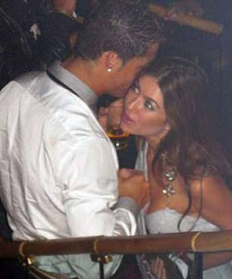](https://1.bp.blogspot.com/-QL3lzWyyNMg/W7TlHPlgMsI/AAAAAAAAAHo/QRLfiWxRiAQ7DVYY6PBtSKUwdQsaNiBJgCLcBGAs/s1600/images%2B%25281%2529.jpeg)

Then she went to the police and reported everything about rape on the same day. Also went to a hospital for examination of sexual assault. But she refused to identify Ronaldo to the police, fearing public humiliation. After a week later, Mayorga named him in a police interview. Then the whole story began.....

**Fixing**

A group of people, who will fix the whole story and keep Ronaldo's reputation an respect untouched. As Ronaldo said, they were "Personal reputation protection specialist". They want to settle things. They even threatend her as having consented sex with him and making a false claim for extorting money from Ronaldo.

On the other hand, she was mentally damaged. Her main fear was public humuliation. The fixers gave her $3,75,000. For that she kept silent.

[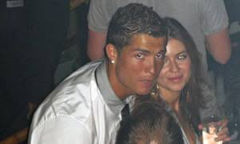](https://3.bp.blogspot.com/-2rA8hh9h72w/W7Tk-qcedII/AAAAAAAAAHk/6hXT0M9hOOwZjYeQk9knrgCClOyZdhZzQCLcBGAs/s1600/images.jpeg)

**RE-OPENING OF CASE**

Then a sports website leaked the copies of documents and communication between Mayorga and fixers. For this Mayorga also decided to come out in public with this incident. And the case re-opened in Las Vegas. As lawsuit, she didn't name Ronaldo in 2009 to the police. Some days ago in a live social media session someone asked him about these things,he refused and claimed that anyone does that for fame and money. But Ronaldo accepts everything about the money, he also said on that night he was gentle, not forced her. (As lawsuit) Now police have the pictures of that night having a conversation with her. And this is an on going investigation.

**Conclusion**

Cristiano Ronaldo has been considered as one of the best footballer. Now this portuguess player, playing in the italian club [Juventus](https://en.wikipedia.org/wiki/Juventus_F.C.). Last year he was accused by spanish authorities for tax evasion but he settled it by paying $21.8 million fine. We have to wait for this case and also wait what is waiting for Cristiano Ronaldo.